G. Rupa Manasa 20-12-2023 Assessment – 15

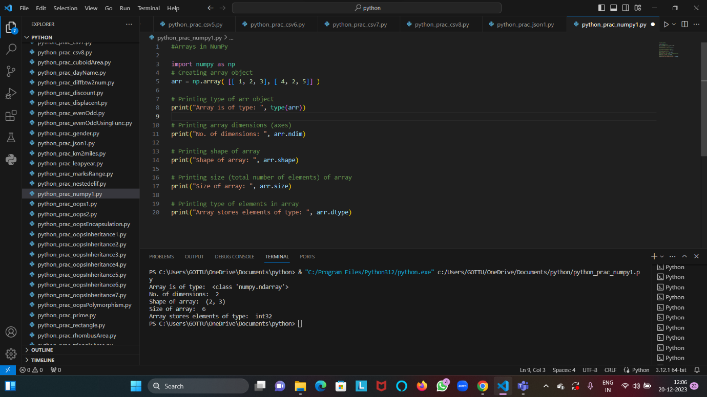

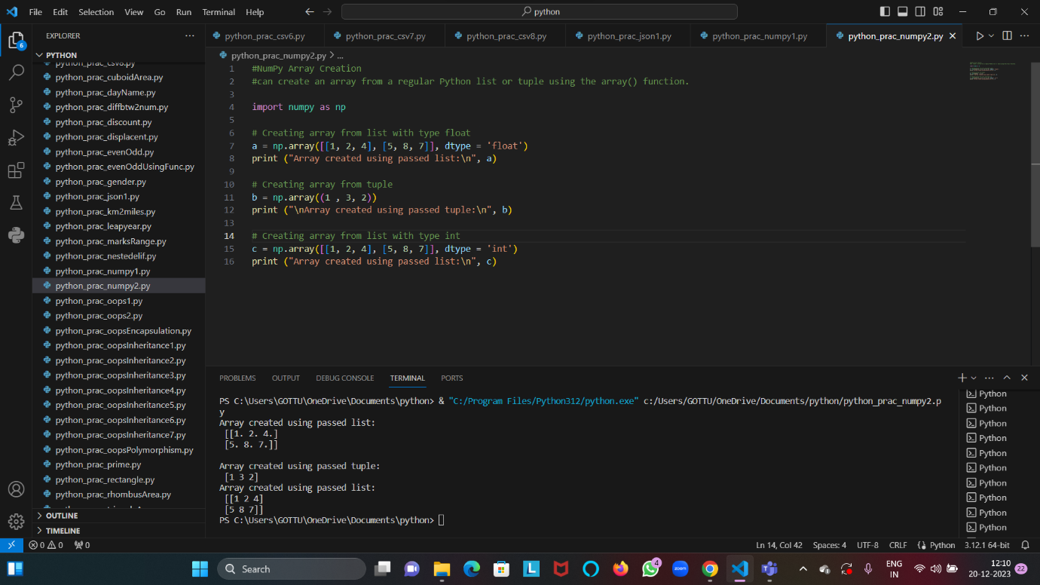

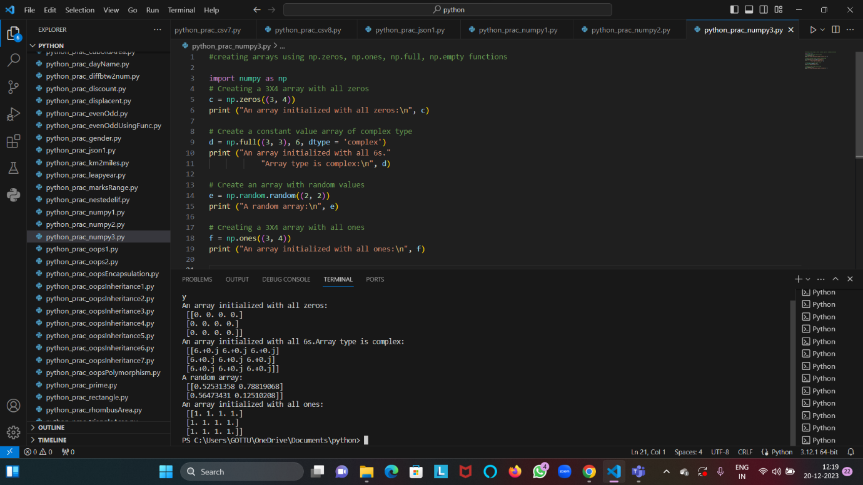

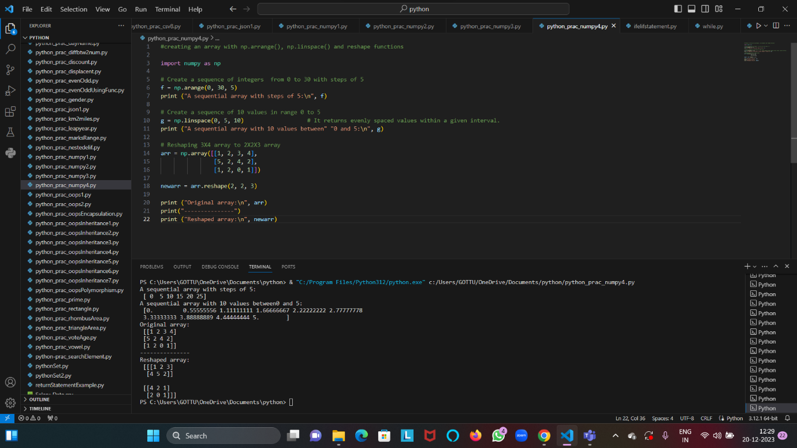

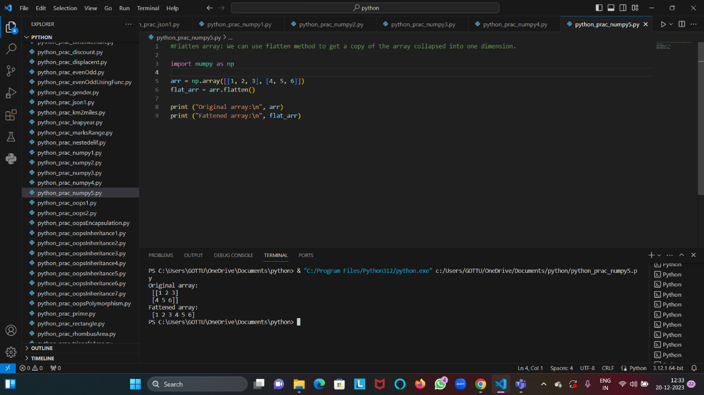

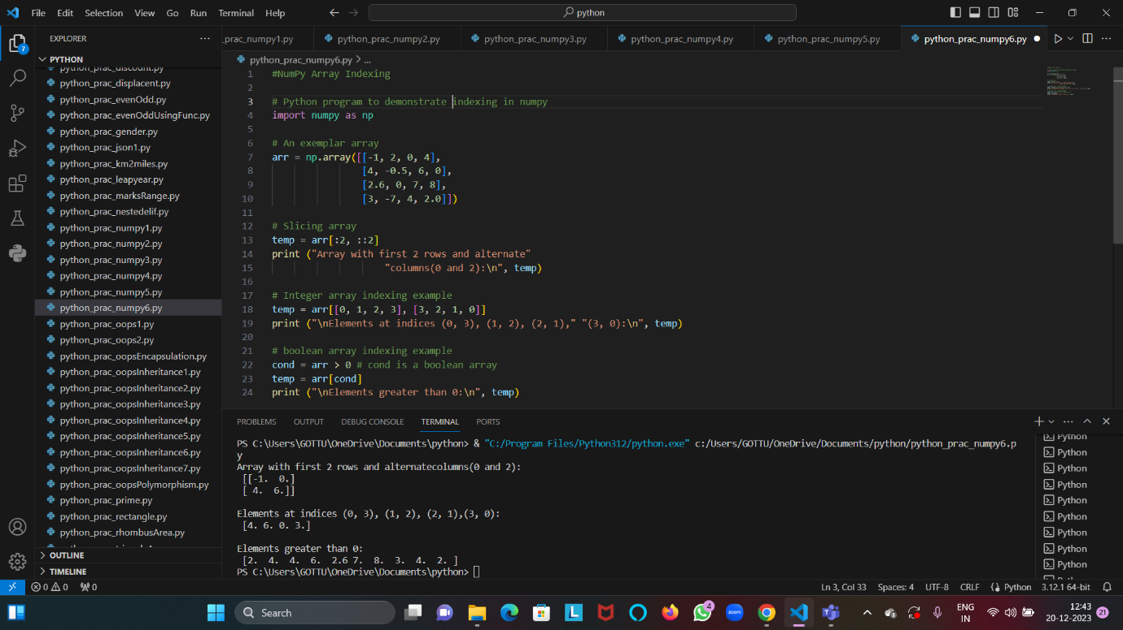

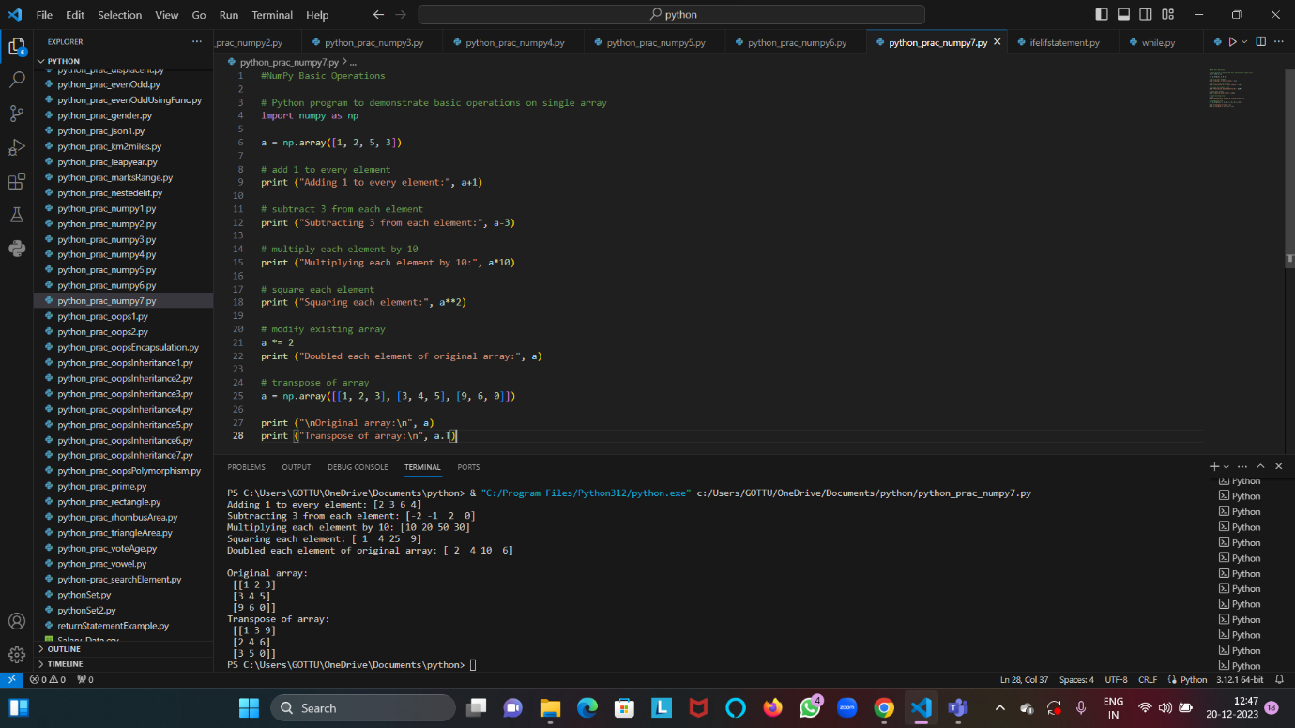

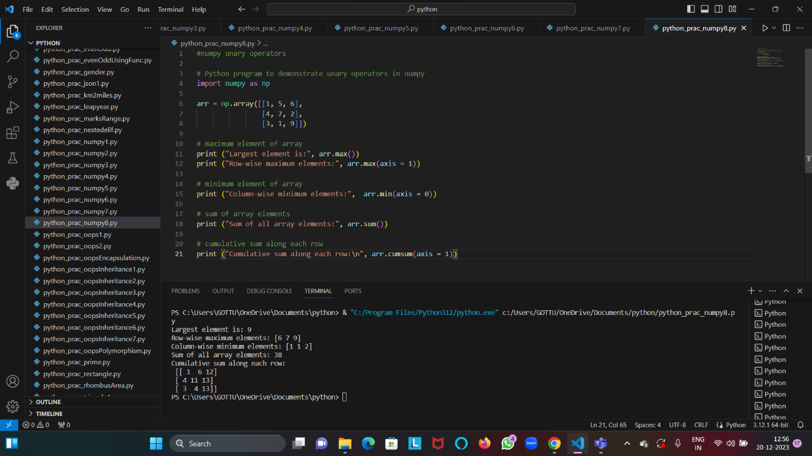

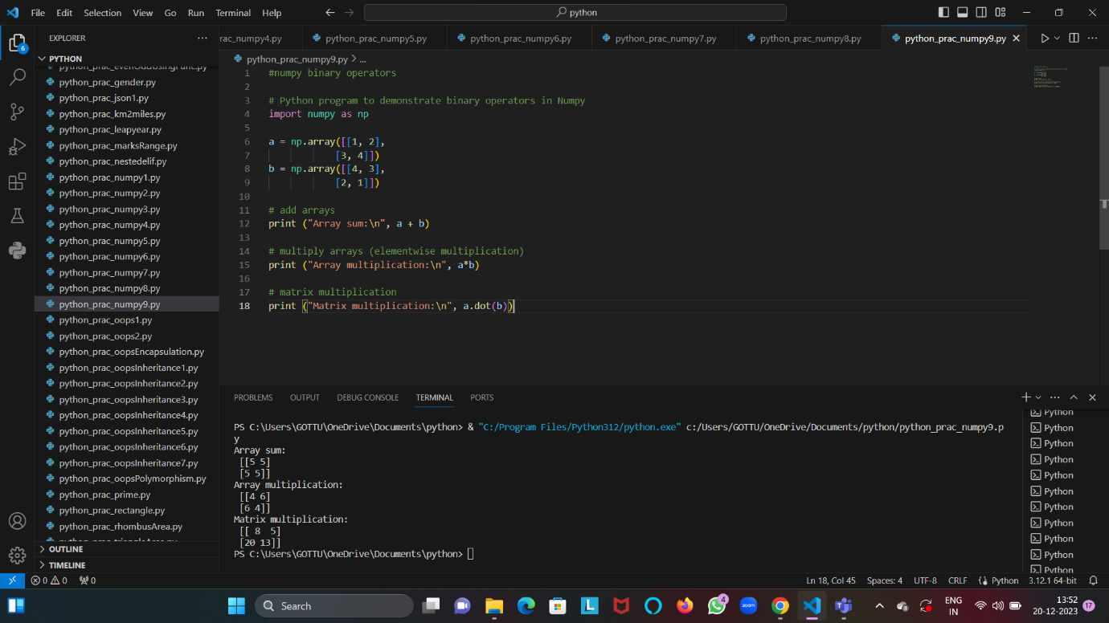

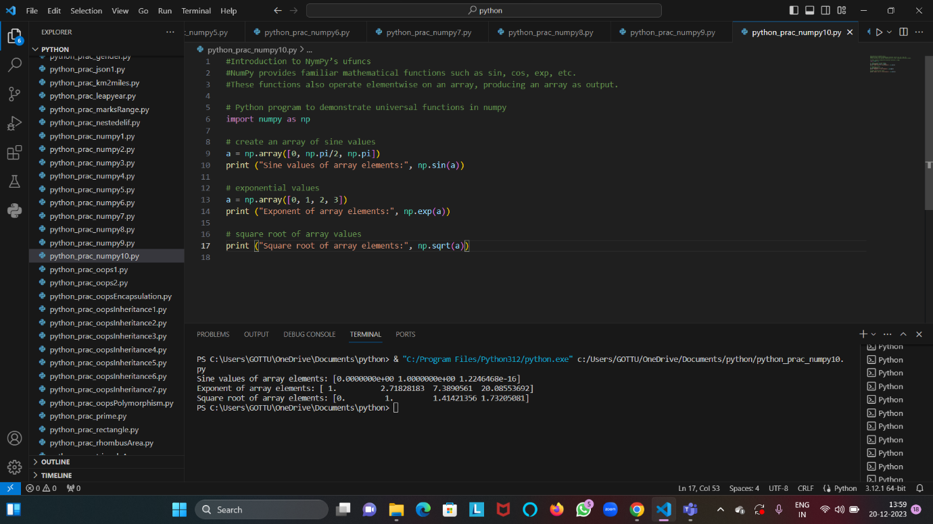

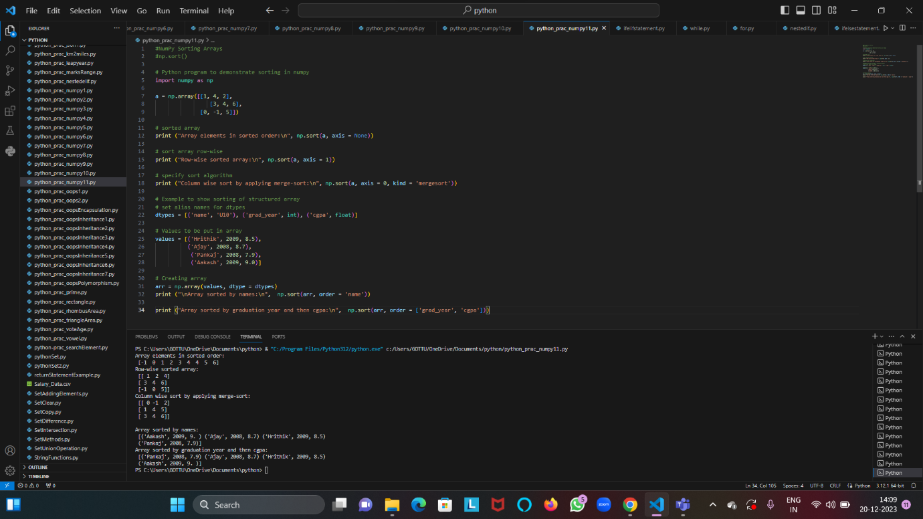

**Introduction to Big Data:**

Big data refers to the massive and complex sets of data that are too large and dynamic to be effectively managed and processed using traditional data processing applications.

These datasets are characterized by the three Vs: volume, velocity, and variety.

**Volume:** Big data involves massive amounts of information. This could range from terabytes to petabytes and beyond.

**Velocity:** The speed at which data is generated, processed, and analyzed.

**Variety:** Big data comes in diverse formats, including structured data (like databases and spreadsheets), semi-structured data (like JSON or XML files), and unstructured data (such as text, images, and videos).

**Structure of Big Data:**

1. Structured
2. Semi Structured
3. Unstructured